Silverton Write-Up
Owen O’Toole, Charlie Stein
Chemistry Period 3
Math 3 Period 4
10/31

Problem Statement
The purpose of this investigation was to predict the water quality of the Animas River below the confluence in Silverton based on measurements from the three tributaries: the upper Animas River, Cement Creek, and Mineral Creek. The measurements were taken on October 12, 2017 from 10:00 to 2:30 in Silverton at each tributary. During the testing process, Owen worked with Evan Roth and John White, and Charlie worked with Kathrine Hjortshoj. During calculations, we worked together.

Introduction
The goal of this project was to determine the water quality of the Animas River below the confluence using measurements from the three tributaries of the river: Cement Creek, Mineral Creek, and the upper Animas River. The measurements we are using are streamflow (cubic feet per second or cfs), turbidity (nephelometric turbidity unit or NTU), pH, conductivity (microsiemens per centimeter or uS/cm), dissolved oxygen (both % saturation and milligrams per liter or mg/L), and temperature (degrees Celsius or C). Streamflow is the amount of water that passes in a certain amount of time, turbidity is the clarity/cloudiness of the water, pH is the acidity or basicity of the water, conductivity is the extent to which the water conducts electricity, dissolved oxygen is the amount of gaseous oxygen dissolved in the water, and temperature is how hot or cold the water is. To calculate the total measurements below the confluence using the measurements of the tributaries, we used standard deviation, which measures the diversity and variability in a data set. We also used weighted average, which calculates how much we should take the measurements of each tributary into account based on its streamflow.

Visual Representations
Table 1: Animas River Complete Data Set
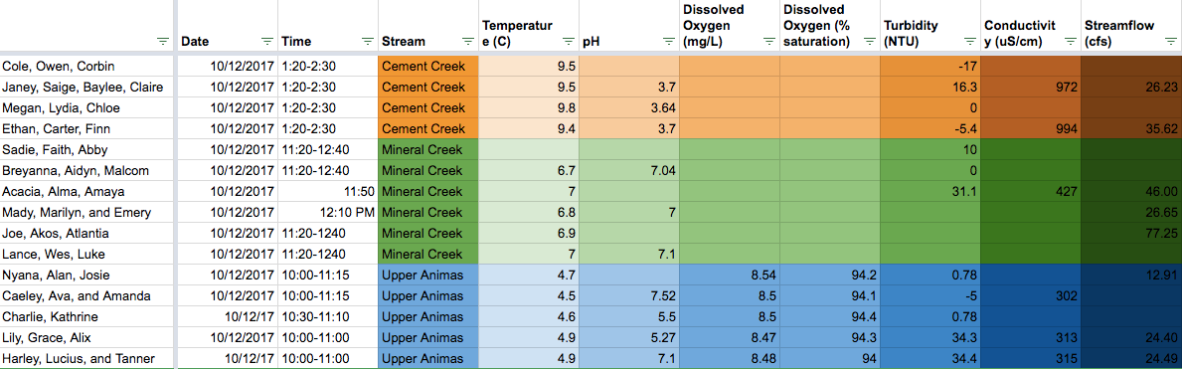
This table is a copy of a Google spreadsheet where the entire class compiled their data. We used this table as a reference to all of our data, and used it to create our pivot tables.

Table 2: Pivot Tables
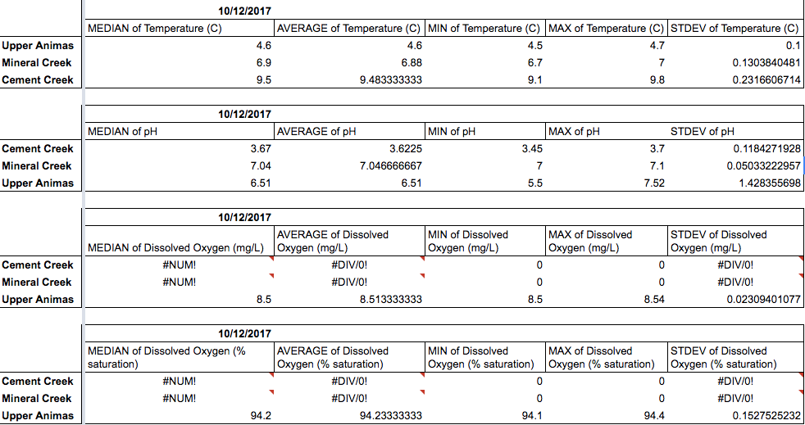
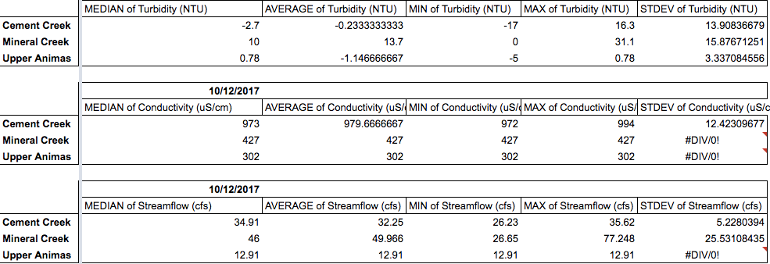
We created these tables using Google spreadsheets. We made a pivot table for each type of measurement, and used them to calculate the median, mean, minimum, maximum, and standard deviation for each measurement of each tributary.

Methods/Process
On October 12, the class took a field trip to Silverton. During the trip, different groups of students went to different tributaries of the Animas River and collected data on the water. We were testing the pH, temperature, turbidity, dissolved oxygen, streamflow, and conductivity. We measured temperature using a temperature probe, which acts like a sophisticated thermometer. We used a pH probe to calculate the pH of the three tributaries of the Animas River. To calibrate the probe, we dipped the probe into two solutions of a known pH. We then measured the pH’s of the different tributaries. For dissolved oxygen, we used a special probe to measure the PPM (parts per million) and the mg/L (milligrams per liter) to determine the amount of dissolved oxygen in the water. We then measured turbidity. Owen did not get to test turbidity, but Charlie did. The first step is to collect water from one of the tributaries and put it into the testing machine. Then the machine does the rest. For conductivity, which only Charlie got to test, the first step is to calibrate it, using the same method of calibration as pH. Then, you put the pronged end of the probe into the water to test the conductivity. The last test involved calculations of the depth, width, and speed of any given tributary, which all contributed to finding the streamflow. We used waders to step into the river throughout the measuring process. First, we stretched a tape-measure across the river to find how far across the river was. Then, we used a yardstick to measure the depth at five points across the river at regular intervals. To calculate the speed of the water, we used a long rod with a propeller at one end that would spin in the water. We put the pole in the water at the same five points where we measured depth. That told us how many cubic feet of water passed per second.

After the field trip, we spent the next few days calculating the water quality of the Animas below the confluence. To do this, we put all our data in a class-wide spreadsheet and made individual copies of them for each group. We then made pivot tables based off the data in the spreadsheet. There was one pivot table for each type of measurement. Within each pivot table, we made a column for the median, the average, the minimum, the maximum, and the standard deviation of the data set. We used these pivot tables to evaluate the accuracy of our data. We did this by comparing the median and the mean. The median is the central piece of data in a data set. The mean is the average of the whole data set, which is found by adding all the data points together and dividing by the number of points. If the median differed too greatly from the mean, we knew that there was an outlier in the data set that was moving the entire mean. If there was, we evaluated the outlier and decided whether or not we should cast it out. We didn’t end up using the minimum, maximum, or standard deviation of the data set because we didn’t know how they would help us evaluate the accuracy of our data. After comparing the median and the mean, we compared our mean with USGS data collected at the same time and place. If it was completely different, we would cast out that data point. If it was similar, we would keep it. Once we knew which measurements were accurate enough to use, we started using them to calculate the water quality below the confluence. First, we added up the average streamflow of each tributary and divided that number by 100. Then, we divided each average by that quotient. This gave us the percentage by which we would take the data of each tributary into account. We checked our work by adding up the percentages and making sure they created 100. Then, we multiplied every piece of data from each tributary by its corresponding percentage.

Solutions/Predictions
The measurements for temperature at the upper Animas are very accurate. We know this because the average and the median are the same, and they line up exactly with USGS data. The measurements for temperature at Mineral Creek are mostly accurate, because there is only a .29% difference between the median and the average, and our data mostly lines up with USGS data. The measurements at Cement Creek are mostly accurate, because there is only a .18% difference between the median and the average, and our data is very close to USGS data.

The measurements for pH at the upper Animas are not accurate, because they don’t line up with USGS data. Our median and mean for pH are 6.51. Our measurements for this were collected between 10:00-1:00 o’clock AM. The USGS measurements at that same time are between 7.7 and 7.8. That’s around a 15.46% difference. That is too big of a difference to consider our results accurate. The measurements for pH at Mineral Creek are not accurate either, because they don’t line up with USGS data. The average pH at Mineral Creek we got was 7.0467, but USGS data says that at the same time, the pH was about 6.75. That’s not an incredible difference, but we only have three data points for the pH at Mineral Creek, and the range is only .1. So there isn’t one outlier in our data set that’s affecting our average. Our entire data set does not line up with USGS. The measurements for pH at Cement Creek are mostly accurate. The USGS data for pH at the time we measured was between 3.55 and 3.6, while our average was 3.6. Our median was slightly higher than our average, but only by 1.29%. Previously, there was a measurement of the pH being 4.6, which served as an outlier and created a larger gap between the median and the mean, and affected the difference between our data and USGS data. Because it was an outlier, we decided to discount that data point. But all in all, because our other pH measurements were inaccurate, we couldn’t find the pH of the river below the confluence.

Dissolved oxygen was not measured at Cement Creek or Mineral Creek, so we can’t predict the levels of dissolved oxygen for the Animas River below the confluence, because don’t know how Cement Creek or Mineral Creek are contributing to them. Therefore, our dissolved oxygen data for the upper Animas doesn’t matter.

The measurements for turbidity at all three of the tributaries are not accurate. The difference between the median and mean for all three are too much to consider the mean accurate, and the USGS data does not line up at all. Therefore, we can’t predict the turbidity of the Animas River.

The measurements for conductivity at the upper Animas are somewhat accurate. There is only a 9.6% difference between the median and the mean. But USGS data shows that at the time we collected our measurements, the conductivity of the water was 338 uS/cm, while our data gives us around 310 uS/cm. The measurements for conductivity at Mineral Creek are somewhat accurate. Our data shows that it’s 427, but USGS data says that it’s around 437. The measurements at Cement Creek are not very accurate. The median and mean are 7.62% apart, which isn’t too much, but USGS data says the conductivity at that time was around 1130 uS/cm. Overall, our data for conductivity does not exactly line up with USGS data. But, because it is otherwise seemingly accurate and is in the same ballpark as USGS, we are going to predict the conductivity anyways, knowing that our prediction will not be very accurate.

The measurements for streamflow at the upper Animas are not accurate. USGS data shows that the streamflow was about 48 cfs, while our data says the average is 20.6. For Mineral Creek, the measurements are not accurate either. USGS data says the streamflow was 39, while we thought it was 49.966. The measurements for Cement Creek on USGS are about fifteen, but our measurements say the average is 32.25, so they are also inaccurate. All in all, our streamflow data is very far off from USGS data. But, since it’s the only source of data we have besides USGS, we used it anyways. But for each prediction, we also made one based off USGS data.

Predictions:
 | Temperature (C) | pH | Dissolved Oxygen ( | Turbidity  (NTU) | Conductivity (uS/cm) | Streamflow (cfs)
AHS Student Data | 6.3 | N/A | N/A | N/A | 576.91149 | N/A
USGS Data | 6.8396884 | 6.7849245 | N/A (no data available) | N/A (used different units than student data) | 497.49260 | 38.293969

Evaluation
This project was enjoyable and educationally valuable. Learning how to manipulate data sets using mathematical tools like weighted average is very valuable. Also, learning how to conduct scientific testing was interesting and worthwhile. The only problem is that, as a class, our measurements were very inaccurate and lead to problems later on. If we could re-do this project, we would get better data before trying to use it to make predictions. But, luckily, we feel like we could do an experiment on our own after this experience.

Importance
It’s important to test our rivers because there are so many environmental factors (especially ones that humans cause) that could negatively affect the rivers. And because we affect the rivers so much, it’s our responsibility to make sure they are healthy. Also, since we use this water, it’s extremely important to know that it’s safe to use. Field tests like the ones we conducted are important, especially when we know of outside factors that could affect them, like the mine spill.

Self Assessment
We think we deserve an A- or a B+, because our report included all the elements required. We were clear in our descriptions and our processes. The only problem is that we weren’t able to get a prediction for every measurement, which could have asked for help with.

