POW 3: Planning the Platforms
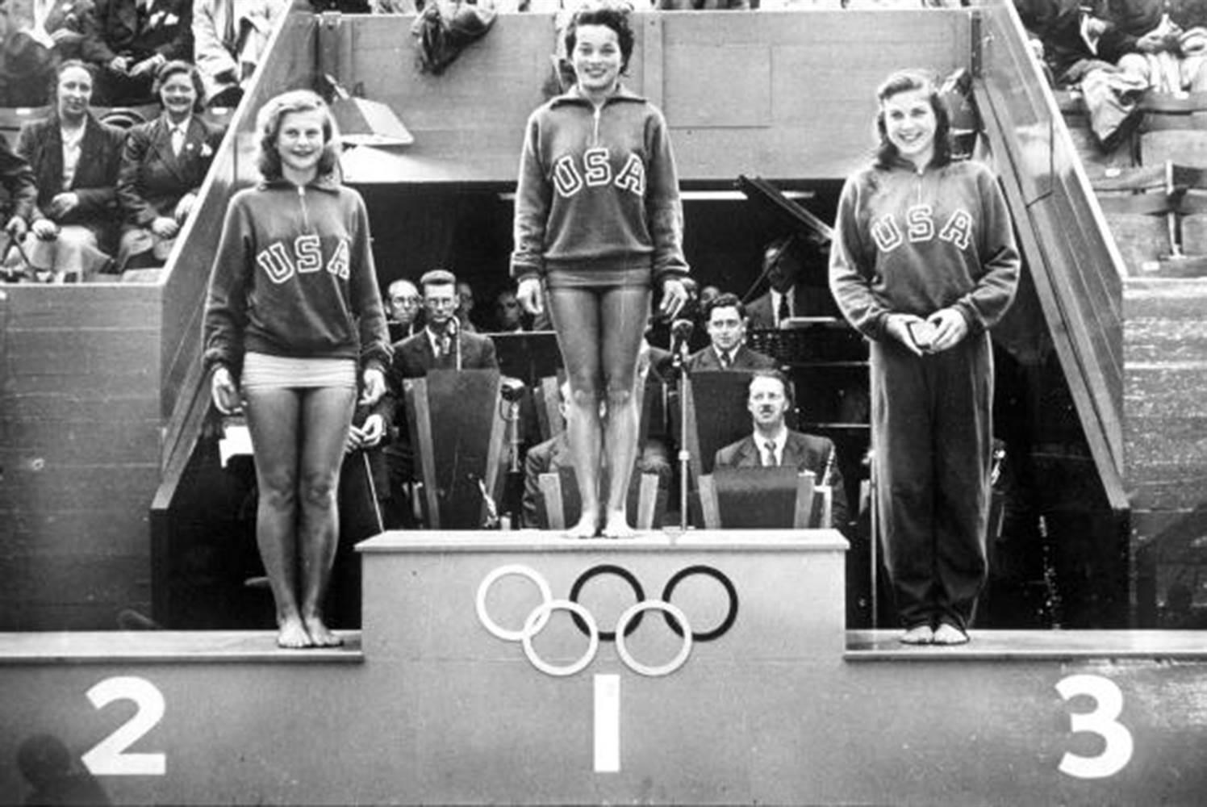
The Platform Display:
River City is getting ready for the big 4th of July band concert that precedes the fireworks. The concert is always a major event, but this year the band leader, Kevin, plans to make it bigger and better than ever.
Kevin wants to have each of the baton twirlers standing on the individual platform, as shown above.
The baton twirlers will toss batons up and down to one another. Kevin wants the difference in height from one platform to the next to be the same in each case.
Kevin’s Decisions:
Kevin has several decisions to make.
- He needs to decide on the number of platforms. (Kevin isn’t sure how many of his baton twirlers will be good enough to perform by the 4th of July).
- He needs to decide on the height of the first platform. (This will depend on how tall the baton twirler on the first platform is, and Kevin hasn’t decided who the first baton twirler will be.)
Camilla’s Dilemma:
Camilla is in charge of building and decorating the structure. She needs a permit from the city to build the structure, so she needs to know how high the tallest platform will be.
She also plans to hang a colorful strip of material on the front of each platform. Each strip will reach from the top of the platform to the ground. (The width of the material is the same as the width of each platform, so she needs only one strip per platform.) She needs to know the total length of material that she should buy.
Camilla is going crazy because she can’t do her job until Kevin makes his decisions.
Your Task:
You are Camilla’s assistant, and she has asked you to be ready to give her the information she needs as soon as Kevin makes up his mind.
Your task in this POW is to create two formulas that will allow you to do this instantly. One formula should tell you the height of the tallest platform. The other should tell you the total length of material that Camilla will need. Your formulas should give these results in terms of the number of platforms, the height of the first platform, and the difference in height between adjacent platforms.
Write-Up:
- Problem Statement

The problem we had to answer was to find 2 different formulas, the first was for how tall the tallest platform was given the distance between all the platforms is the same and that there could be any number of platforms and the distance between them is unknown, the second was to find how much cloth would be needed to cover the fronts of all the platforms. Simple, Right?
- Visual Representation

- Process

So basically what I did was just thought about what I had to figure out, and I had a breakthrough. Sad T. I was just going over different formulas and plugging numbers and variables in and I stumbled across y=mx+b, I adapted the formula to fit the equation better because when you think about it, all this is is just a different style of graph

So using y=mx+b wasn't too farfetched. This led me to the conclusion s+ad=t or “SAD T” as I call it. Is a lot less complicated than it sounds.
Key:
S is the shortest/smallest platform
A is the amount of platforms minus one, I couldn't get it to work without the minus 1. So it can't just mean simply exactly what it looks like it means. :(
D is the distance between platforms
T is the tallest platform

T

This made the second part infinitely easier all I had to do was figure out the height of all the platforms using the formula I developed for part one, “Sad T”, I discovered that all you needed to do was use Sad T to find the tallest platform, then use sad to to find the number of platforms and the smallest platform, then find the different distances between the platforms using the power of reasoning. Then you add all the platform heights together and as the french say: идеально which means perfect in spanish, I think. I put lots of effort into this pow so I think I should get an A. :D

